Ipomoeae batatas
The sweet potato is a food source growing as the tuber of the Ipomoeae batatas. It has it’s origin in south america and has later been introduced in area’s such as the Philippines, Japan and Africa. Which is evident because we can see that it mainly grows on the west coast of Southern-America and Middle-America (Figure 1.). Also it has some occurences in middle asia. And rare occurences in Africa and through the rest of America.
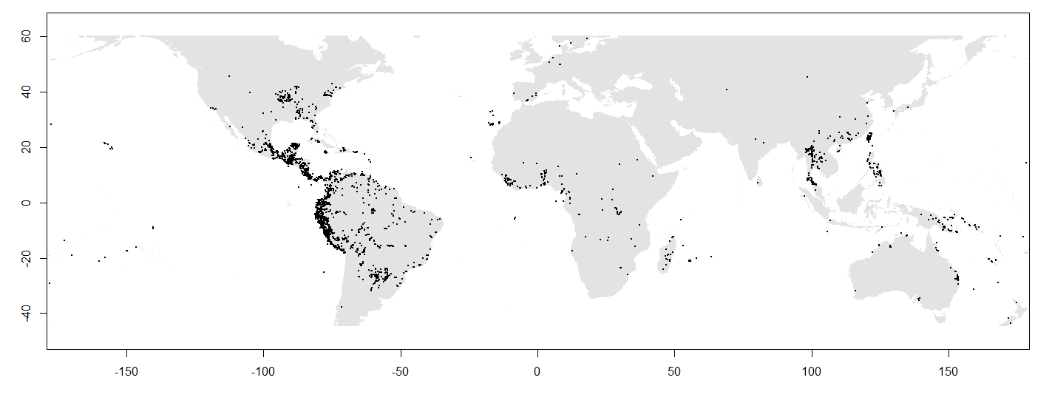
Figure 1.Occurence of Ipomea batatas
Methodology
I used the future predictions for 2070 with rcp8,5 which is the worst scenario, because this species already lives in very warm area’s and will less likely be negatively impacted by warming and might take longer to see differences.
I used Bio2, 7, 12 and 14 as variables. This because it is a crop growing in tropical area’s (Figure 1) and these area’s usually have little variation in temperature which is shown in bio 2 and 7 and these area’s are usually also very moist. Therefore, I used bio12 and 14 because these include total precipitation and the minimum in a month. This might be very limiting because it does not occur in area’s with very distinct seasons.
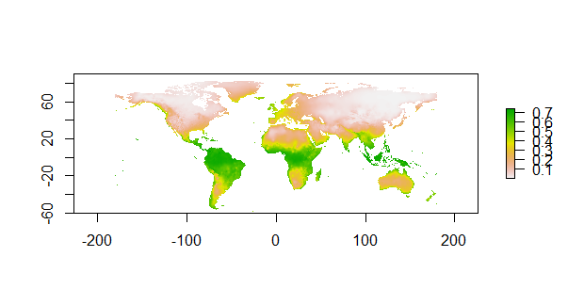
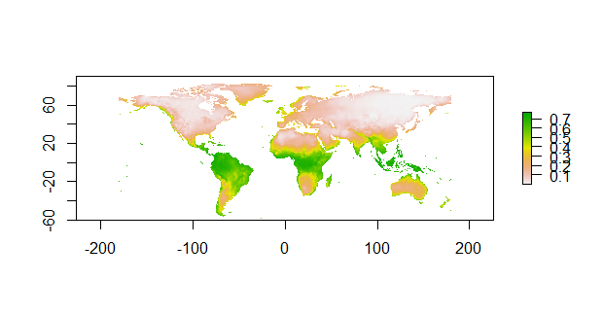
In maxent I used the linear and quadratic features because these are shown to best show species distribution models.
Figure 2.
Present global distribution Future global distribution
Model output
Both the present and future global distribution are shown (Figure 2.). We do not see a lot of difference, which means that it has already occupied much of the area’s that it will be able to occupy in 2070. The clipped global distributions are not shown because the species has occurrences that are global, therefore, the clipped and total do not differ.

The AUC gives a reasonable performance of 0.729. This is not exceptionally good but better than random values.
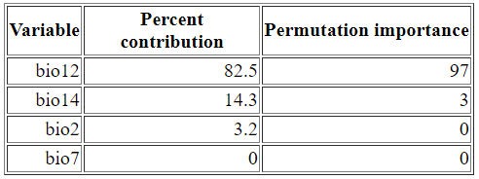
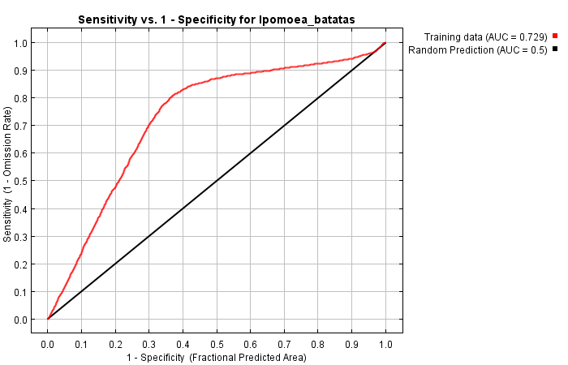
Figure 3. UAC
The variable importance table shows that bio12, the annual precipitation is the most important variable. This is also what I expected based on that most occurrences are in the tropics. Which are generally very humid so this is probably important for the species.
Cumulative threshold | Logistic threshold | Description | Fractional predicted area | Training omission rate
1.000 | 0.169 | Fixed cumulative value 1 | 0.962 | 0.037
5.000 | 0.208 | Fixed cumulative value 5 | 0.832 | 0.072
10.000 | 0.251 | Fixed cumulative value 10 | 0.707 | 0.091
0.000 | 0.002 | Minimum training presence | 1.000 | 0.000
11.921 | 0.265 | 10 percentile training presence | 0.667 | 0.100
37.447 | 0.448 | Equal training sensitivity and specificity | 0.300 | 0.300
30.651 | 0.392 | Maximum training sensitivity plus specificity | 0.370 | 0.192
0.000 | 0.002 | Balance training omission, predicted area and threshold value | 1.000 | 0.000
8.353 | 0.239 | Equate entropy of thresholded and original distributions | 0.745 | 0.086

The table above shows that the maximum training sensitivity plus specificity give a value of 0,392. This is used to say when individuals will occur at a certain place in the change map given below. This gives that if the suitability is above 0,392, it will occur.
In figure 4 we can see the present suitable habitat which spans the globe on the middle latitude and some coastal areas at higher latitudes. In figure 5 we can then see the change of suitable habitat in 2070 with rcp 8,5 and we can see that not very much changes except for Europe (blue is loss of suitable habitat, green in increase and yellow is habitat that remains suitable)(It is made blue instead of red because otherwise I am not capable of seeing the difference). The largest part of Europe is lost as suitable habitat in this climate scenario. Overall there is a very slight shift north because area is lost at the south side and gained on the north side of current habitat.
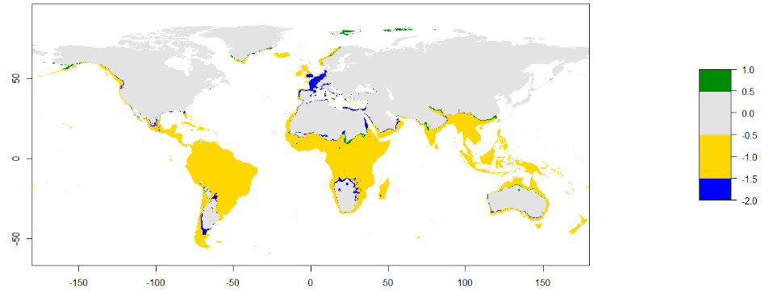
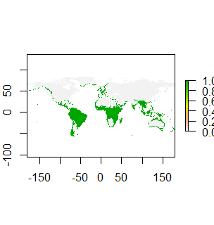

Figure 4. Present suitable habitat (left) and predicted suitable habitat change (right)

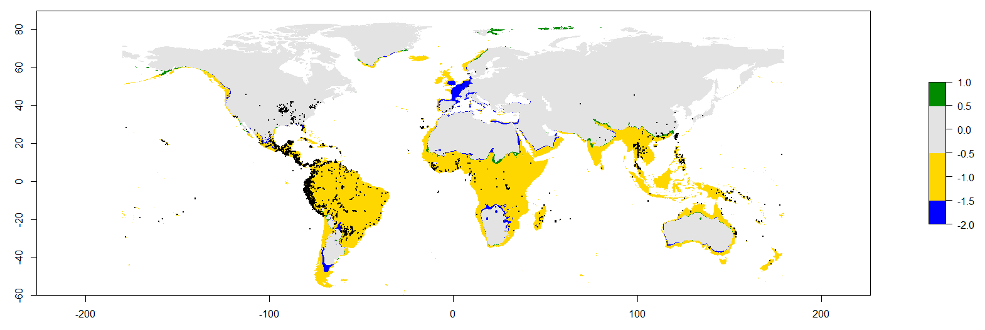
Figure 5. Suitable habitat change with occurrence
We can very clearly see that the suitable habitat does not change much in the place where the species most occurs. This will, therefore, not have a large impact on the species. The biology of the species will thus not change a lot because of the abiotic factors associated with climate change. Especially because we are looking at the most severe situation. What we do see is that the species is capable of growing in larger area’s than where it is grown at present. If other species would be impacted largely by climate change, the Ipomea batatas could be a solution to decreasing crop, as it could instead be grown. The model is useful in that it gives insight in other places where it could be grown but it is very clear that the biotic factors and the dispersal attributes are the limiting factors in the spread of the species. We can clearly see that it has a large area where it could possibly grow but where it doesn’t. This must be due to dispersal limitations or necessary interactions with other species et cetera.
Overall this model could prove useful to gain insight in a crop that is very capable of dealing with climate change, but to fully exploit the possibilities, human intervention is probably needed to get the crop to grown elsewhere.

Philip Bijl 1560883

